Project 9: Ultrasonic Avoidance Smart Car
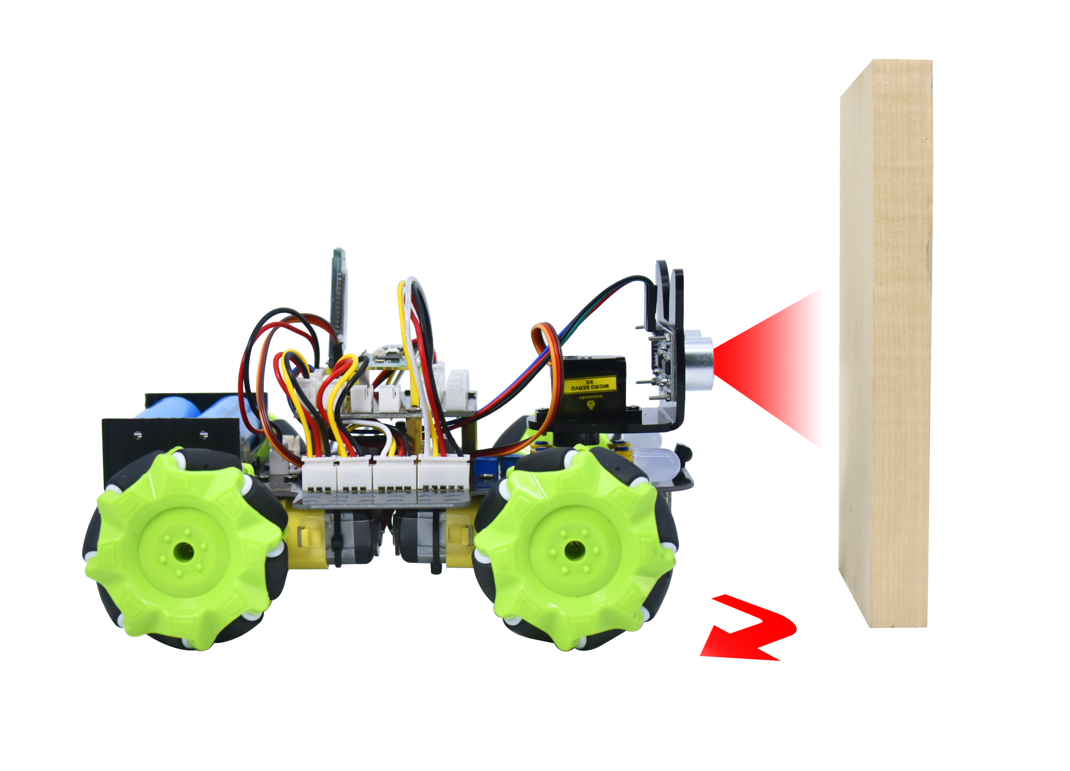

1. Description
Ultrasonic avoidance smart car is used to control the car motion state, so as to achieve obstacle avoidance by using the ultrasonic sensor detecting the obstacles distance.

- Flow Diagram
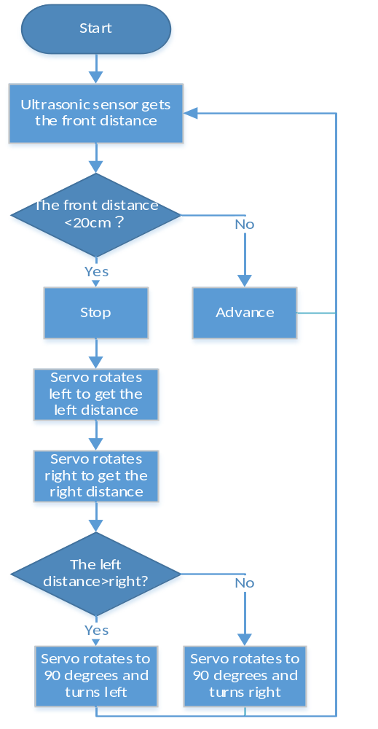

3. Test Code
/*
Keyestudio 4WD Mecanum Robot for Pico
lesson 9
Ultrasonic obstacle avoidance Robot
http://www.keyestudio.com
*/
#include "MecanumCar_v2.h"
#include "Servo.h"

mecanumCar mecanumCar(20, 21); //sda-->20,scl-->21
Servo myservo; //Define an instance of a servo

/*******Ultrasonic Sensor interface*****/
#define EchoPin 4 //ECHO to GPIO4
#define TrigPin 3 //TRIG to GPIO3

int distance_M, distance_L, distance_R;

void setup() {
myservo.attach(2); //The pins of the servo is connected to GP2
pinMode(EchoPin, INPUT); //The ECHO pin is set to input mode
pinMode(TrigPin, OUTPUT); //The TRIG pin is set to output mode
myservo.write(90); //Rotate to 90 degrees
delay(100);
}

void loop() {
distance_M = get_distance(); //Get the distance and save in the distance variable
if (distance_M < 20) {//When the distance in front is less than 20cm
mecanumCar.Stop(); //Robot stop
delay(500); //Delay in 500ms
myservo.write(180); //Ultrasonic cradle head turns left
delay(500); //Delay in 500ms
distance_L = get_distance(); //Assign the left ultrasonic distance to variable a1
delay(100); //Read values when stable
myservo.write(0); //Ultrasonic cradle head turns right
delay(500); //Delay in 500ms
distance_R = get_distance(); //Assign the right ultrasonic distance to variable a2
delay(100); //Read values when stable

myservo.write(90); //Return to the 90 degree position
delay(500);
if (distance_L > distance_R) { //When the distance on the left is greater than right
mecanumCar.Turn_Left(); //Robot turns left
delay(300); //Turn left 700ms
} else {
mecanumCar.Turn_Right(); //Robot turns right
delay(300);
}
}
else { //If the distance in front >=20cm时，the robot will advance
mecanumCar.Advance(); //Advance
}
}

/*********************Ultrasonic detects the distance*******************************/
int get_distance(void) { //Ultrasonic detects the distance

int dis;
digitalWrite(TrigPin, LOW);
delayMicroseconds(2);
digitalWrite(TrigPin, HIGH); //Give the TRIG a high level of at least 10 µ s to trigger
delayMicroseconds(10);
digitalWrite(TrigPin, LOW);
dis = pulseIn(EchoPin, HIGH) / 58.2; //Work out the distance
delay(30);
return dis;
}

4.Test Result
After uploading the code successfully and power up, and the car can automatically avoid obstacles. Note that the speed can’t be too large.

The car will stop when encountering obstacles in front of it and the servo cradle head will rotate left to detect the left distance, then rotate right to detect the right distance. Then judge the distance between the obstacles on the left and the right, the car will turn along the farther side, and then continue to drive.

5. Code Explanation

myservo.write(90); | Make the servo rotate to 90 degrees
int distance = get_distance(); | Define an integer variable to store the measured distance, and then control the car driving according to it
myservo.write(180);  distance_L = get_distance(); | Ultrasonic turns left to detect and save the distance
myservo.write(180);  distance_L = get_distance(); | Ultrasonic turns right to detect and save the distance
myservo.write(90); | The servo return to the 90 degrees position
if (distance_L > distance_R) | Judge the left and right distance
else {  mecanumCar.Advance();  } | If the front distance is bigger than 20cm, the car will advance

